Assignment (4)

1. Create a file (testcomp) and save some info inside

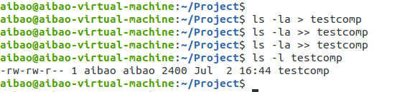

1. Compress the file using gzip method, what is the size before and after compression

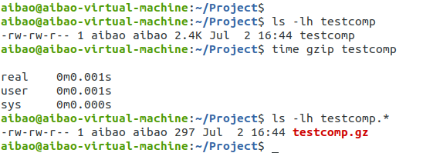

1. Compress the same file using bzip2, what is the file size before and after compression?

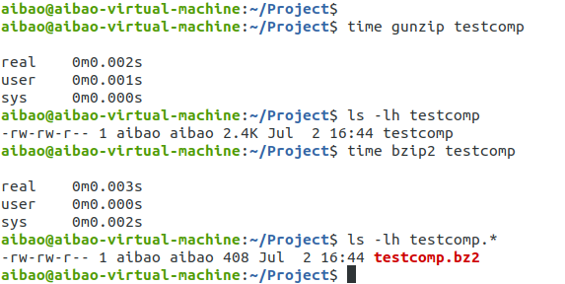

1. Program for Best Fit algorithm and the worst fit in Memory Management

Input : blockSize[] = {100, 500, 200, 300, 600};

processSize[] = {212, 417, 112, 426};

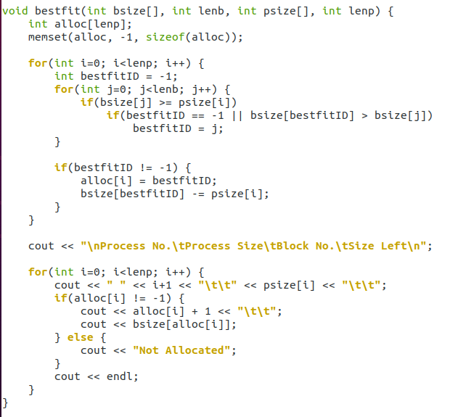

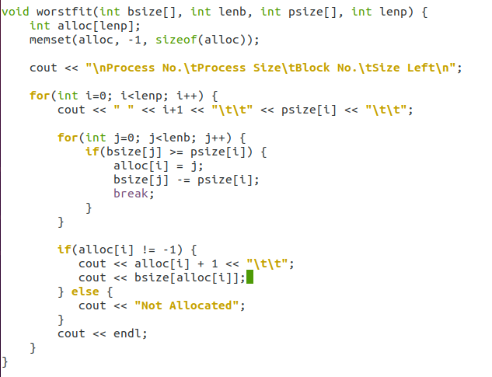

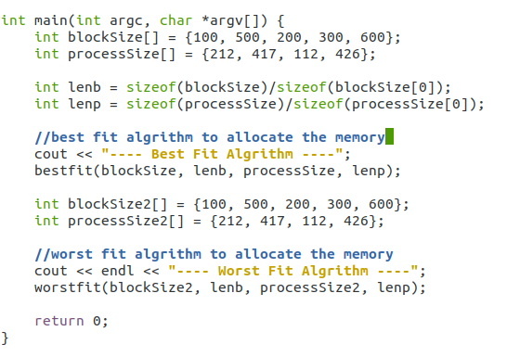

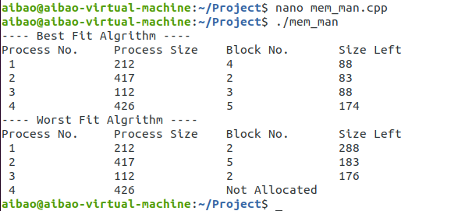

1. using shell script, design a log in check system that checks the user name and the e password

1-Ask the user to enter the user name (hint: read command is used to get the input from the user)

i.e. read name … this command will get thae entered name from the user and save it in a variable name

2- ask the user to enter the password.

3-If the entered user name and password are correct, print out “log in is successful”

4-Print out ”log in failed” for any other case

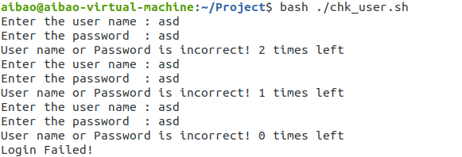

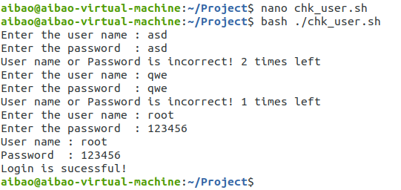

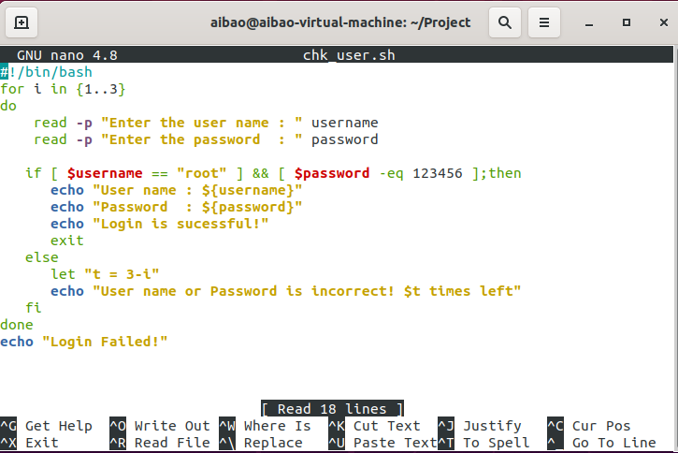

1. using Perl script, design a log in system that creates an account to the user

1-Ask the user to enter the user name

2- ask the user to enter the password the password should be longer than 6 characters and less than 9.

3-if the condition is correct print out “account created successfully”

4-if not print out ”password is to short ” or “password is too long” according to the cas

